DATA VISUALIZATION:
Project : Tic-tac-toe using reinforcement learning.

Dataset is as follow:
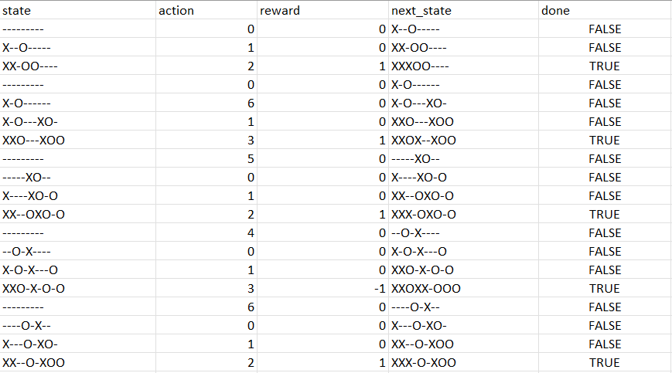

Reward Distribution Graph
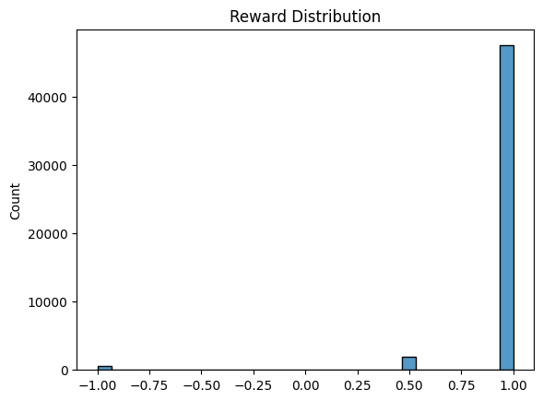

#Moving Average Reward
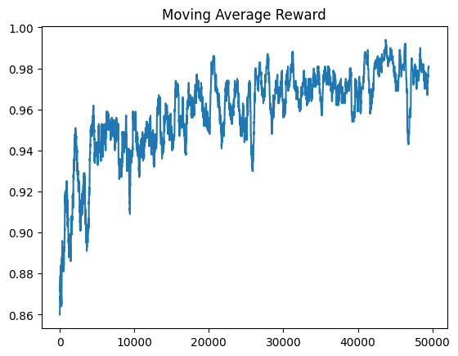
#Q-Value Heatmap (Empty Board)
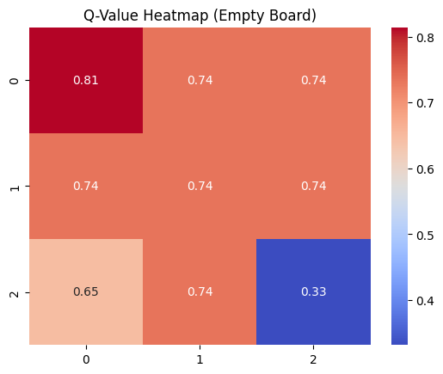
Best-Action-Distribution
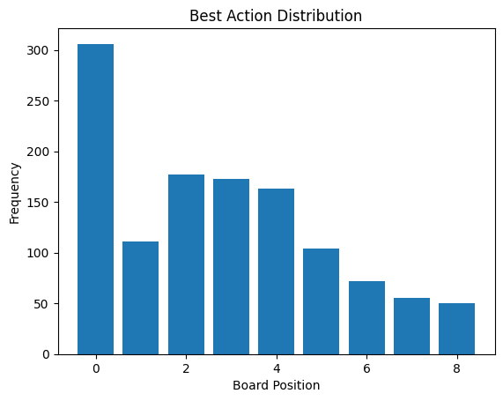
Q-value Correlation Map
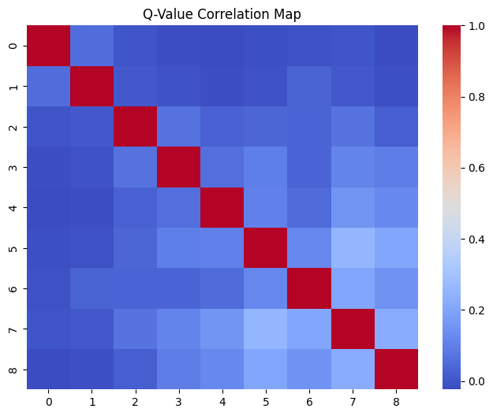

Game-Outcomes
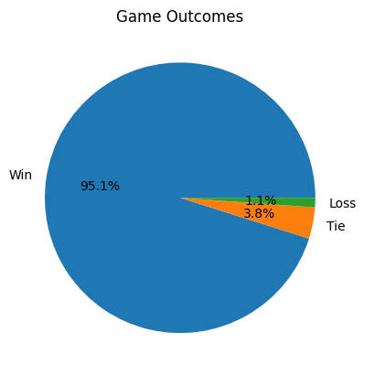
Reward box plot :
The reward box plot demonstrates low variance and high median reward, indicating convergence to a near-optimal policy with predominantly winning outcomes.
